**Exercise no:**2

**Register no:**1518102710

**Date:**17.10.2020

**Aim:**

To print the count number x in a given list of numbers.

**Program:**

def countX(list,x):

s=0

for i in range(len(list)):

if(list[i]==x):

s+=1

return s

list=[]

n=int(input())

for i in range(n):

list.append(int(input()))

x=int(input())

s=countX(list,x)

print(s)

**Link:**

<http://103.53.53.18/mod/vpl/forms/edit.php?id=230&userid=1713>

**Output:**

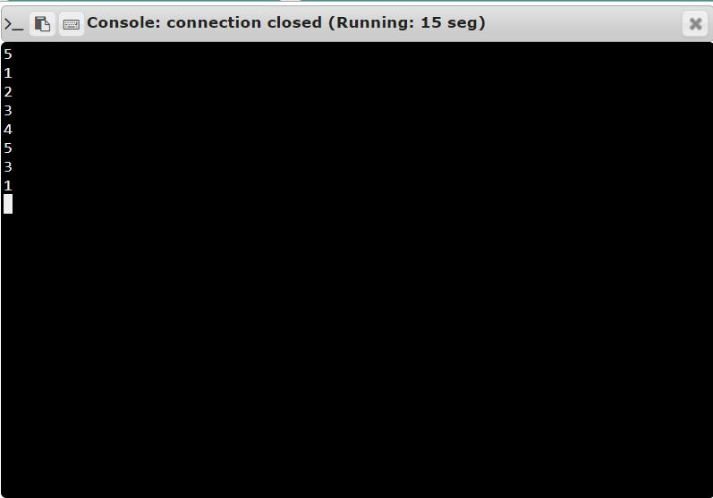

**Result:**

Thus the code has been successfully executed and output is verified.